CEO Letter
Through this space, I firstly, welcome you, and I hope that you find what you are looking for with us.
As it's known, the dental equipment & supplies trading and marketing sector in Yemen, has witnessed developments in the recent period. In light of these developments and fierce competition, Mohammed Abdullah Hajar Company has become a famous name for our customers. Our company is known for providing high-quality dental supplies and equipment products from well-known international agencies. Moreover, our methods of dealing and our work policies that based on honesty, transparency and on-time delivery are the main aspects behind our growth and success we have achieved over the years.
In our field of work, and in light of the fierce competition in the dental products market, we have been keen to compete fairly and maintain a friendly and good relationship with other companies. Also, our customers' satisfaction is our goal, and for this reason we meet the needs and expectations of our customers to the fullest and at the best competitive prices. Our existing clients consider us a trusted partner.

About us
Mohammed Abdullah Hajar Trading Company, a dental supplies equipment center, was established in 1994. The company's headquarters are located in the Yemeni capital, Sana'a. Since its establishment, we have been providing everything new and distinctive in the world of dentistry to the Yemeni market. Therefore, we are keen to select the finest products from well-known European and international agencies and make them available to our customers. In light of the prosperity and growth of dentistry and the fierce competition in the Yemeni market, our focus and keenness to be the pioneers in the field of preparing and marketing dental supplies, so we focus mainly on the quality of what we offer, thus achieving leadership and distinction in the Yemeni market, and gaining a good and excellent reputation on a wide scale. In response to the increasing demand in the market, we have expanded our activity and our work team in order to keep pace with the rapid development in the field of dentistry, while emphasizing that our first priority remains to provide the highest international standards in terms of product quality and the best prices for the local market. Developing and improving the company's commercial position and its excellent relationship with the companies it represents or with its customers is the core of all our work and activities. In addition to the above, we would like to emphasize that we are keen on fair and free competition and maintaining friendly and good relations with other companies.
Our message | Our Vision | Our Values
We are committed to providing innovative and reliable solutions that enhance efficiency and effectiveness for all our customers, ensuring a sustainable relationship based on a solid foundation of trust and mutual respect. | Our vision is to contribute in making a qualitative shift in dentistry in our beloved country by providing the finest and latest products and supplies in accordance with the highest international standards. | Honesty, quality, respect and trust above all else, and based on these values ​​we seek to provide products that include an easy-to-use experience for dental specialists and technicians while providing after-sales support to our customers and our network of agents.

Why Quality?
Dental care is an essential part of maintaining good overall health for both children and adults. We believe that everyone should be able to receive the best possible dental care. To do so, we are committed to providing high quality dental supplies and equipment from reputable European and international agencies. One of our distinguished products in the Yemeni market is the dental impression, where We provide a wide variety of dental impressions from the best ever produced. This greatly meets the requirements and aspirations of Dentists and prosthodontists.

Source of our products
Since we began our activity in the world of dental equipment and supplies in 1994, our focus has been to supply the Yemeni market with high-quality products. Since then, we have focused our efforts on searching for those sources that provide dental equipment and supplies products. Therefore, we have chosen European and international agencies, holding a high reputation and are trusted by millions of dentists and dental technicians around the world, to be their sole agents and distributors in the Republic of Yemen. The essence of dentistry is precision, and this is what our agency's products provide.

Cavex  Since 1908, Cavex has been developing and manufacturing premium solutions for the dental industry. From the beginning, all company operations were carried out in-house in Haarlem, the Netherlands. Each new Cavex product is the result of extensive collaboration between the R&D, organization, production, marketing, sales and logistics departments. This enables Cavex to develop, produce and distribute high quality products worldwide. | 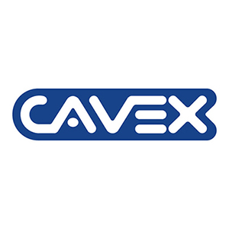
Zhermack  Zhermack is an international company providing advanced materials and solutions to the dental, industrial and health sectors: three divisions, to meet the market with excellent solutions. Founded in 1981, Zhermack is today part of the multinational company Dentsply Sirona. Zhermack is a leader in the dental impressions sector worldwide, producing alginate, plaster and silicone composites worldwide. | 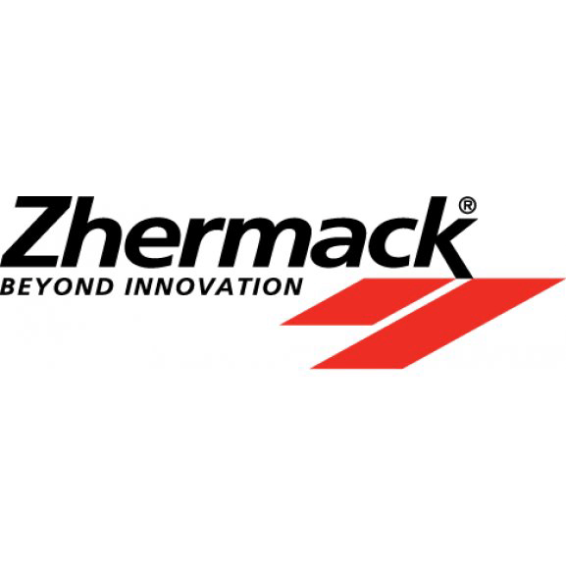

Dentamerica  Dentamerica Inc. was founded. Founded in 1986, its headquarters are located in City of Industry, California, USA. We are fully committed to continuing innovative research and development in advanced dental technology, and vigorously improving the global competitiveness of our products. Our products are distributed through a global network of sales agents around the world. Our brand image is unparalleled. | 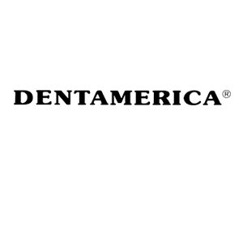

Anthos  The leading Italian manufacturer of dental units, products designed to ensure that all dentists have a model that suits their individual working style. For over 60 years now, the wide product range, premium design, officially recognized quality and excellent performance have made this brand a popular choice with dentists around the world. | 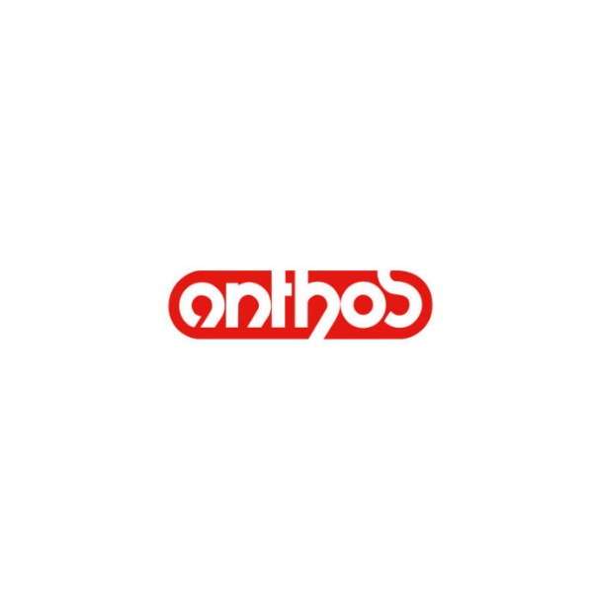

Dentalfilm  The Italian Dentalfilm Company is considered one of the leading and distinguished companies in the production and manufacture of high-quality self-developing dental X-ray films. | 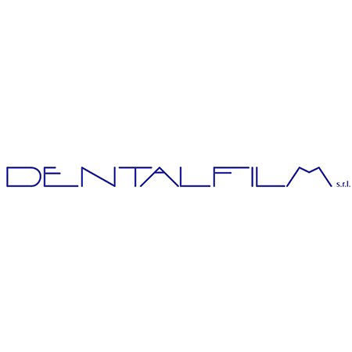

Founded in 1922, Kemdent is a registered brand of Associated Dental Products Ltd, based in Swindon, England, and has gained many decades of experience in the dental profession. This brand has become synonymous with quality and is popular among dentists and dental technicians. Kemdent is a leading manufacturer of first-class dental materials and products worldwide. | 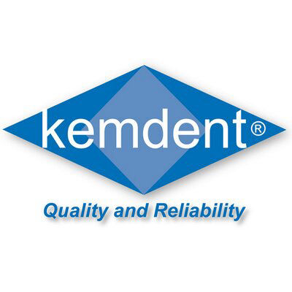

The leading Italian manufacturer of dental units, products designed to ensure that all dentists have a model that suits their individual working style. For over 60 years now, the wide product range, premium design, officially recognized quality and excellent performance have made this brand a popular choice with dentists around the world. | 

Address: | Rep of Yemen, Sana'a, 20th meter road ST, Al-zera'ah crossroad.
Mobile: | 00967-777-106-599
Sales: | 00967-1-218750
E-Mail: | ahmed.hajar@hajardental.com
Accounting E-mail: | accounting@hajardental.com
Wbsite: | https://www.hajardental.com
Working Hours: | From Sat - Thu /  08:30 AM - 01:00 PM  04:00 PM - 08:30 PM

